Chapter 2: Algorithm Discovery and Design
- Pseudocode is a tool for designing algorithms but does not run on a computing device.
伪代码是用于设计算法的工具，但不能在计算设备上运行。
- Pseudocode lies somewhere between natural language and programing language and is used to design algorithms prior to coding them.
伪代码位于自然语言和编程语言之间的某个位置，用于在对它们进行编码之前设计算法。

The addition algorithm of Figure 1.2 expressed in natural language
用自然语言表示的图1.2的加法算法
Figure 1.2 :
Initially, set the value of the variable carry to 0 and the value of the variable i to 0. When these initializations have been completed, begin looping as long as the value of the variable i is less than or equal to (m - 1). First, add together the values of the two digits a_{i} and b_{i} and the current value of the carry digit to get the result called c_{i} Now check the value of c_{i} to see whether it is greater than or equal to 10. If c_{i} is greater than or equal to 10, then reset the value of carry to 1 and reduce the value of c_{i} by 10; otherwise, set the value of carry to 0. When you are finished with that operation, add 1 to i and begin the loop all over again. When the loop has completed execution, set the leftmost digit of the result c_{m} to the value of carry and print out the final result, which consists of the digits c_{m} c_{m-1…}c₀. After printing the result, the algorithm is finished, and it terminates.
首先，将变量进位的值设置为0，将变量i的值设置为0。完成这些初始化后，只要变量i的值小于或等于（m-1）。 首先，将两个数字ai和bi的值以及进位数字的当前值相加，得到结果为ci。现在检查ci的值以查看它是否大于或等于10。如果ci大于 等于10，然后将进位的值重置为1，并将ci的值减小10； 否则，将进位的值设置为0。完成该操作后，将1加到i并重新开始循环。 循环完成执行后，将结果cm的最左边数字设置为进位值，并打印出最终结果，该结果由数字cm cm-1…c0组成。 打印结果后，算法完成，然后终止。

In Programming language:
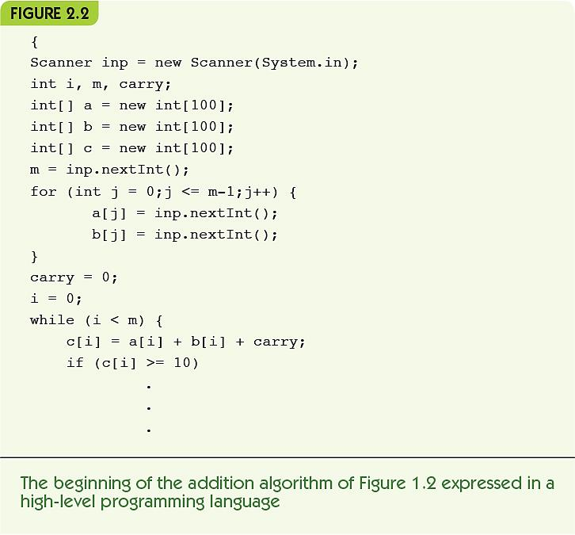

Sequential operations perform a single task顺序操作执行单个任务
The three basic sequential operations: 三个基本顺序操作：
- Computation: a single numeric calculation计算：单个数值计算
- Input: gets data values from outside the algorithm 输入：从算法外部获取数据值
- Output: sends data values to the outside world输出：将数据值发送到外界
A sequential algorithm is made up only of sequential operations顺序算法仅由顺序运算组成
A variable is a named storage location to hold a data value变量是用于保存数据值的命名存储位置
- Example: computing average miles per gallon
Step | Operation
1 | Get values for gallons used, starting mileage, ending mileage  获取使用的加仑，开始里程，结束里程的值
2 | Set value of distance driven to (ending mileage - starting mileage)  设定行驶距离为（结束里程-起始里程）的值
3 | Set value of average miles per gallon to (distance driven ÷ gallons used)  将每加仑平均英里的值设置为（行驶距离÷加仑）
4 | Print the value of average miles per gallon
5 | Stop

- Control operation: changes the normal flow of control控制操作：改变正常的控制流程
- Conditional statement: asks a question and selects among alternative options:
条件语句：提出问题并在其他选项中进行选择：
- Evaluate(评估) the true/false condition
- If the condition is true, then do the first set of operations and skip the second set
如果条件为真，则执行第一组操作并跳过第二组
- If the condition is false, skip the first set of operations and do the second set
如果条件为假，则跳过第一组操作并执行第二组操作

Example: check for good or bad gas mileage示例：检查汽油里程好坏
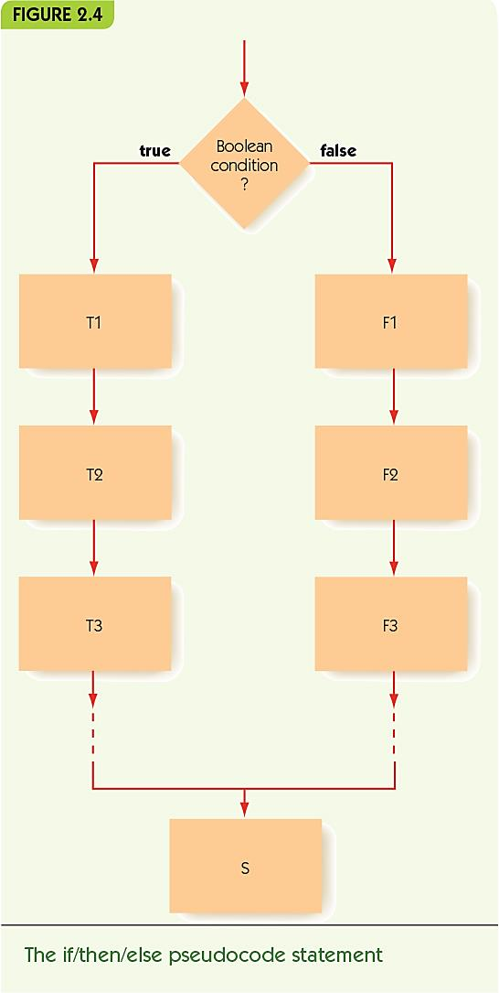

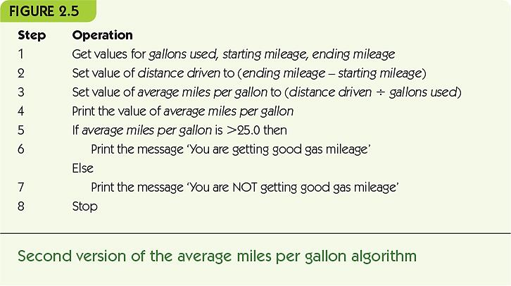
- Iteration: an operation that causes looping, repeating a block of instructions
迭代:导致循环，重复指令块的操作
- While statement repeats while a condition remains true当条件保持为真时，While语句重复
Continuation condition: a test to see if while loop should continue
延续条件:测试while循环是否应该继续
Loop body: instructions to perform repeatedly
循环体:重复执行的指令
- Example: repeated mileage calculations
例如:重复的里程计算
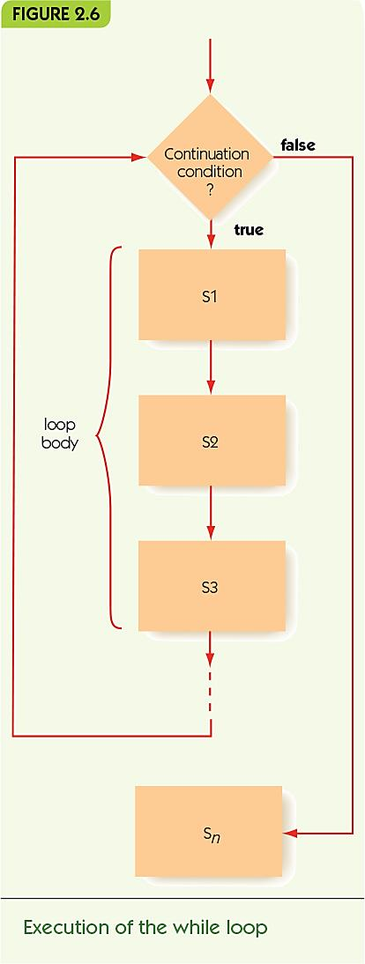

Representing Algorithms Iteration(迭代) and Loop Body(循环体)
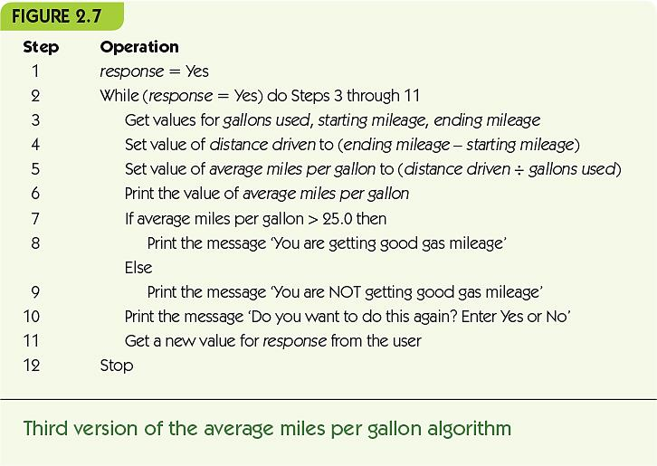

- Do/while, alternate iterative operation交替迭代操作
Continuation condition appears at the end 延续条件出现在末尾
Loop body always performed at least once 循环至少执行一次
- Primitive operations: sequential, conditional, and iterative are all that is needed
基本操作：只需进行顺序操作，条件操作和迭代操作

Representing Algorithms Do/While Posttest Loop
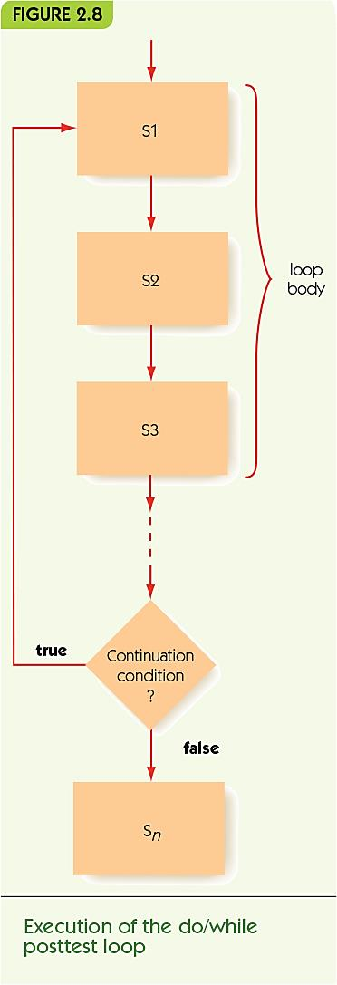
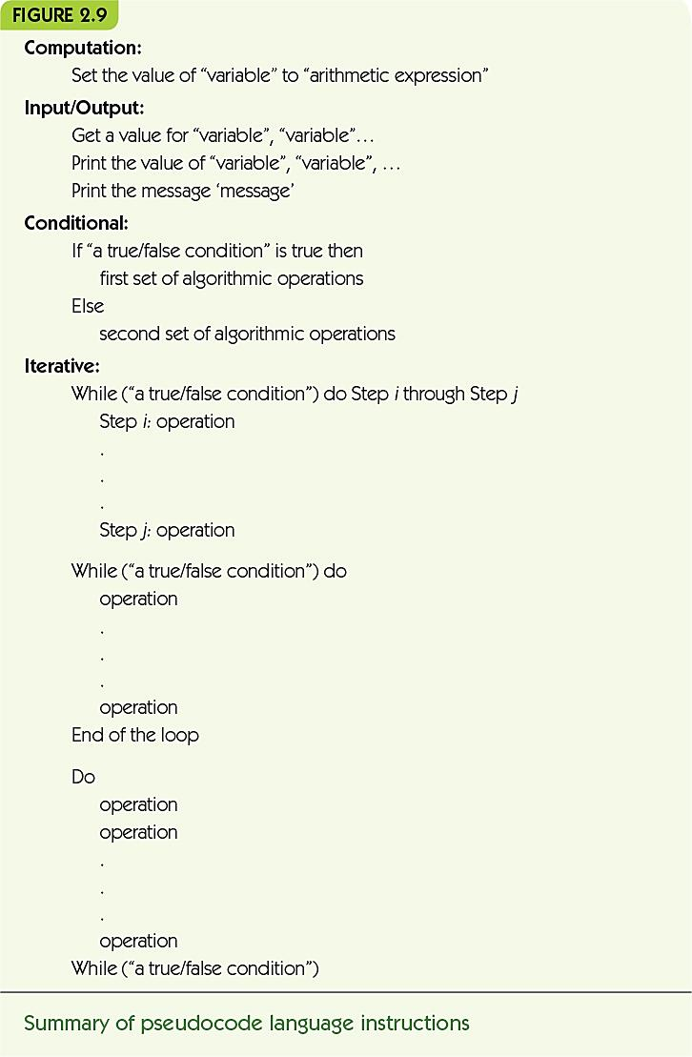

Summary
- Pseudocode is used for algorithm design: structured like code but allows English and mathematical phrasing and notation
伪代码用于算法设计：结构类似于代码，但允许使用英语和数学措辞及表示法
- Pseudocode is made up of sequential, conditional, and iterative operations
伪代码由顺序，条件和迭代操作组成
- Algorithmic problem solving involves: 算法问题解决包括：
Step-by-step development of algorithm pieces
分步开发算法部分
Use of abstraction and top-down design
使用抽象和自上而下的设计

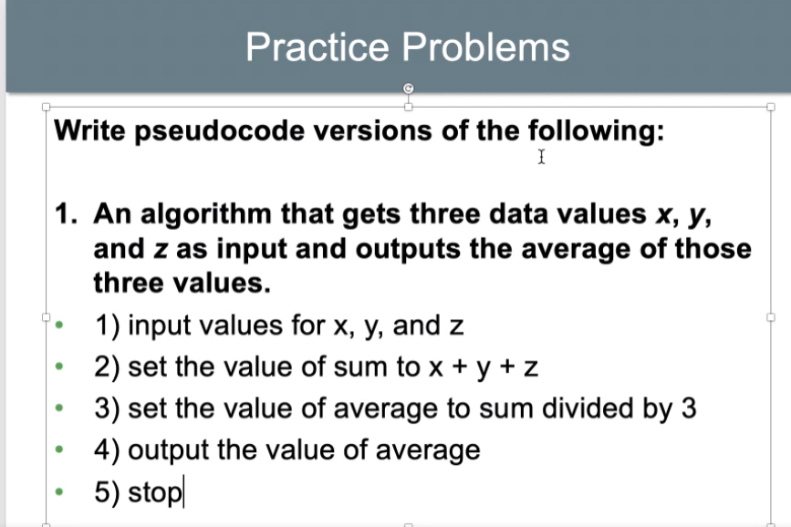
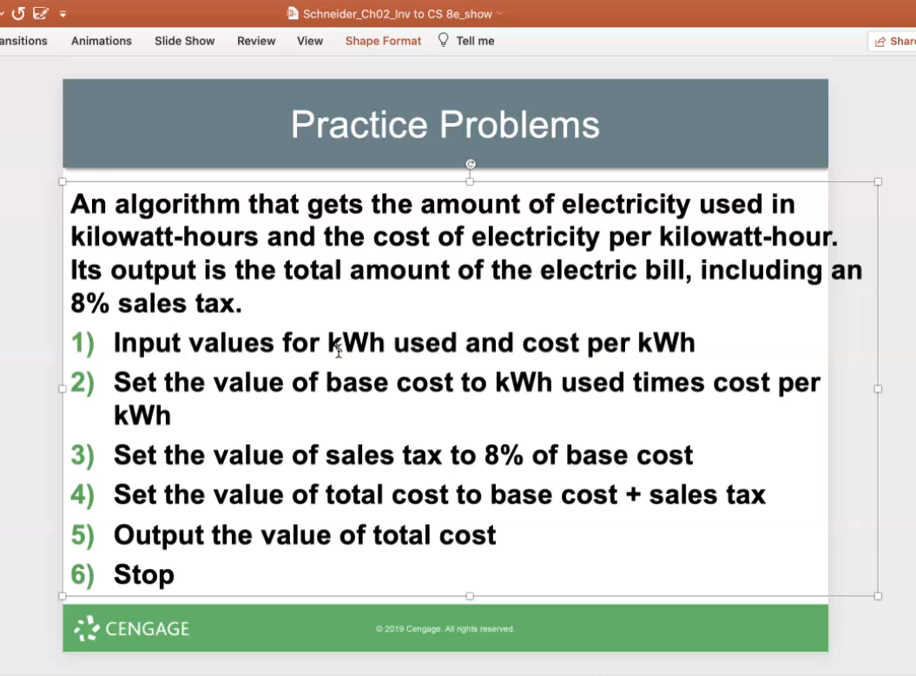
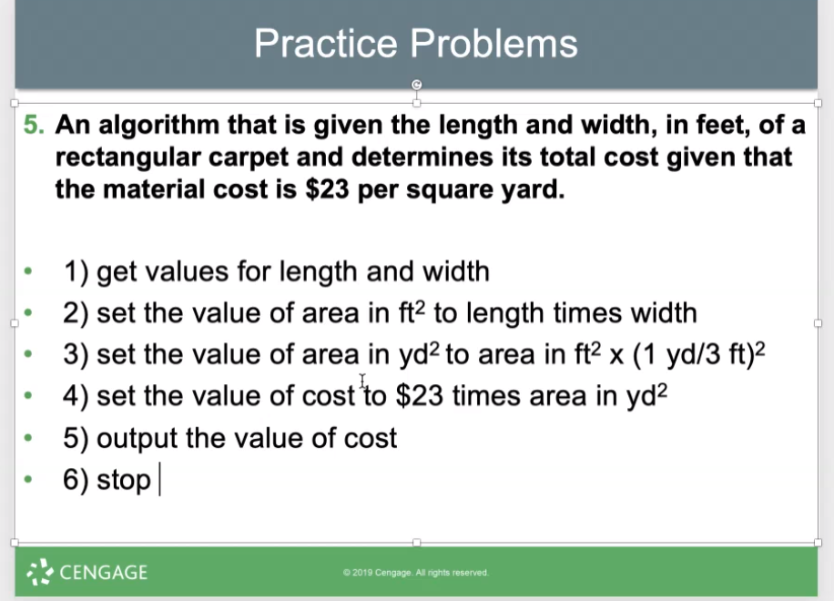
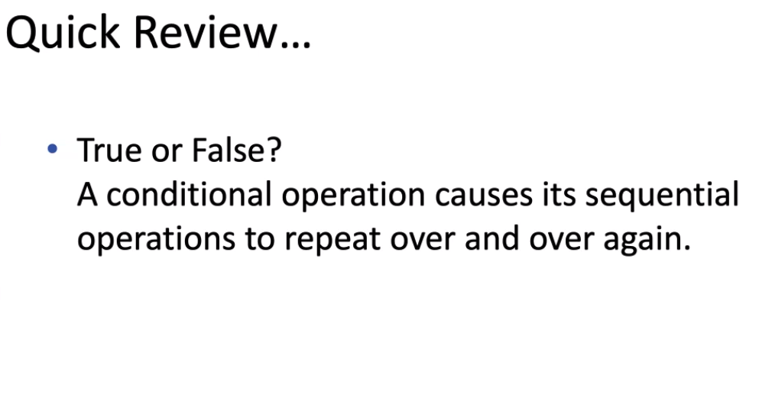
False

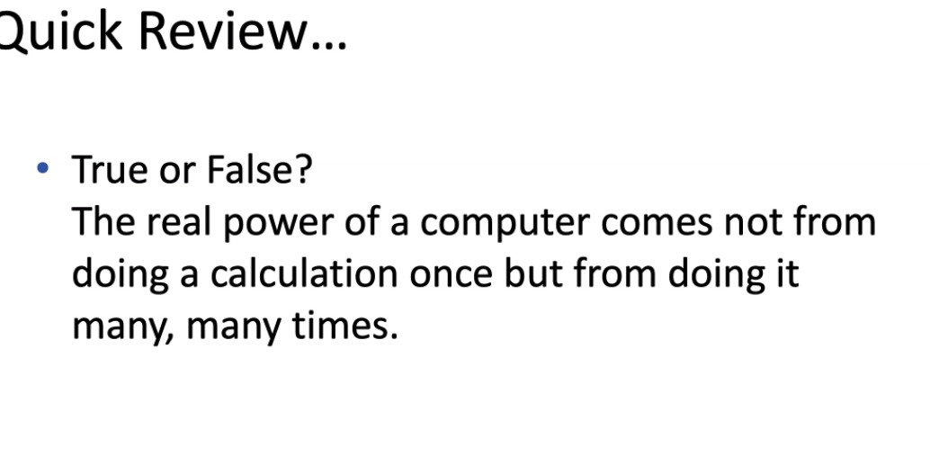
False

